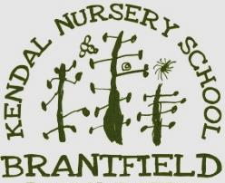
Kendal Nursery School Newsletter
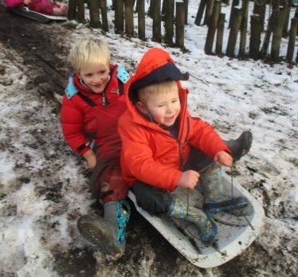
Dear Parents and Carers,
A big welcome to any new families who have joined us in January, the new children seem to have settled in really quickly into their classrooms.

We are looking forward to another fun packed half term at Kendal Nursery School. Last week children had a fabulous time out in the snow…. Can we just ask parents to keep the children’s bags topped up with fresh clothes so we can change them easily when they get wet or muddy!! Don’t forget to put socks in their bags as well we always run out of spares!!!

Our brand new website will be live next week, www.brantfield.com. We have had a lot of technical issues with the old one so have had to start again with a whole new website!! Our new website is packed full of more up to date pictures of the children who attend Nursery School showing off all the fun they have. In the meantime remember to like us on Facebook to keep in touch with any updates and reminders. Our Facebook link is : https://www.facebook.com/brantfieldnursery/

Alyssa Dobbs
Headteacher
Thursday 1st February at 4pm 2018 | Friends of Brantfield Meeting
12th February – 16th February 2018 | February Half term holidays – school closed
Tuesday 6th March 9.30 -10.30am | Phonics is fun – workshop for Parents
27th and 28th March 2018 | Formal parents evening
30th March – 21st April 2018 | Break up for Easter holidays – school closed
1st May 2018 | Informal Parents evening
7th May 2018 | May Day Bank Holiday
28th May – 1st June 2018 | Half term
20th July 2018 | Break up for Summer holidays
Dates for your Diary:

Friends of Brantfield
We are always looking for new faces to join our Friends of Brantfield group. The group meet regularly to organise fund raising and lots of the fun stuff we do at Kendal Nursery School.

We are currently looking for fresh ideas for our next fund raising event and really want to encourage more new faces at the next meeting. If you are interested in getting involved please join us on Thursday 1st February at 4.00pm at school.
Phonics is fun workshop for Parents
Tuesday 6th March 9.30 -10.30am
This session is aimed mainly at parents whose children are going to Primary school in September. We will cover what sorts of things we do at Nursery, how to make phonics fun and age appropriate and we will look the best ways to continue the phonics journey at home ready for them starting school.
Please speak to Alyssa if you would like to attend.
Holiday Club
Holiday club will run again during February half term (12th – 16th February). Most children who need holiday club are now already booked in. We do still have a few spaces left so if you haven’t got your child’s name down and you could do with some holiday hours then please speak to Karen or Josie and we can book a place for your child.

Holiday club runs from 8.00 – 5.30pm each day.
Dino Dinosaur funds : in December contribution to the Dinosaur added up to £25.02
In January across the classes and afterschool clubs we will be making pizzas, baking cakes, testing Chinese food, playing with rice, enjoying gloop and loads of other fun stuff.
A big thankyou to all the parents who have been putting donations in our ‘donation dinosaur’, unfortunately with budgets ever tightening its getting harder to do all the extras without your donations – please give generously as we couldn’t afford all this fun without your contributions!!

Emergency school closure because of severe weather
We are committed to keeping the school open and only in the event of severe weather conditions will the school be closed. If school do have to close due to severe weather conditions we will try to contact Parents by text. Please ensure that we have an up to date contact number.

If we do have to close we will also inform local radio (Lakeland radio) and post information both on our facebook site and on the council website www.cumbria.gov.uk/schoolclosures letting you know.
Please bear in mind that school will be open providing it has all its services (heating, water, etc.) and enough staff to operate effectively. We may not be able to let you know whether the school is closed before 8.00 am as we need to give our staff the opportunity to attempt to get to school.
Driving up the drive
Thank you so much to all the parents who have been parking on the road and walking up with your children.
We must insist that parents do not come up the drive to drop off or pick up children at busy times. The barrier is often closed at these times to remind parents but if its open please do not sneak up as it causes chaos and it is not safe for children and parents walking up the drive!!
Please do not drive up the drive at these times
8.50am – 9.20am
11.50am – 12.10pm
2.45pm - 3.15pm
Many thanks for your help on this.

Keeping Under Fives Safe Online
Now the internet is much more accessible for children we wanted to give you some useful information to help keep your children safe online. This leaflet has been taken from the Keeping Under 5’s safe online website which is fantastic for relevant advice and information:
http://www.childnet.com/parents-and-carers/hot-topics/keeping-young-children-safe-online
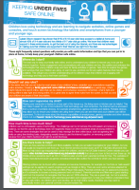
Another good resource for parents to look at and share with your child is the online story ‘Digiduck’s Big Decision’ http://www.childnet.com/resources/digiducks-big-decision

You can find links to both websites on our new website.

School Angel fund raising
Please remember that you can support Brantfield by going through ‘School Angel’ if you are ordering things online. There is no cost to you and we receive a percentage of your order. You don’t need to register or put any detail in, just go to our website www.brantfield.com and click on the ‘School Angel’ link towards the bottom of the front page. You can still use all the major online retailers – Amazon, Argos, Next and so many more including holiday companies, please take a look!
Parents Evenings
On the 27th and 28th March 2018 we will be holding a formal parents evening for all children due to start Primary school in September 2018. Parents will be able to book individual appointments to speak with their child’s class teacher. If your child attends the Nursery School but is not yet old enough for school this September then we will be holding an informal parents evening on 1st May.

We will send out more details about the Parents Evenings nearer the time.

