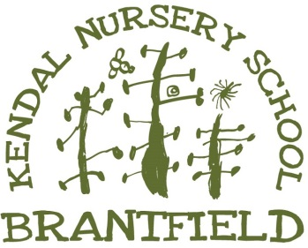
Pupil Premium at Kendal Nursery School

September 2024 statement

What is Early Years Pupil Premium?
From April 2015 Nursery Schools are able to claim extra government funding through the Early Years Pupil Premium to support children's development, learning and care. The Early Years Pupil Premium (EYPP) provides funding for three and four year old children whose parents are in receipt of certain benefits or who were formerly in local authority care but who left care because they were adopted or were subject to a special guardianship or child arrangements order.
Our school is able to claim this supplementary funding of £302 per year for each three and four year old that meets the national eligibility criteria. The principle behind the additional funding is to support the school to continue to improve children’s outcomes and to boost achievement of children who may be disadvantaged.
- This extra funding may be used to support pupils in a variety of ways/ this may include:
- Targeted interventions for smaller groups of children or 1:1 to support communication, language and literacy or maths support
- Nurture group work to enhance children’s self-esteem, confidence and positive attitudes to learning
- Additional resources and/ or staff training to meet specific needs
Staff quickly identify and target any gaps in children’s learning and development. Staff carefully track and analyse pupil progress to ensure that these pupils are given the support they need to achieve their expected progress.
What did we do with the pupil premium money last year? 23/24
Our pupil premium money for 2023-24 was used towards an additional member of staff in the preschool room enabling small group work and support with toileting etc.
We also subsidise a place in our outdoor class so vulnerable children can also access this provision. Amazingly a parent has also contributed the money this year to subsidise another place as they could see the impact and benefit for children to access this provision. This has doubled the number of children allowing two places per day in this wonderful provision.
Using the money for an additional adult has really allowed us to support children’s language and communication skills as well as helping children’s self-help skills. Staffing ratios in the outdoor class are on a 1:5 level so children are able to be supported and nurtured helping develop their confidence and self-esteem. This also gives additional opportunities to work collaboratively alongside other children whilst participating in exciting activities that promote awe and wonder.

EYPP - Kendal Nursery school Sept – 2023 - 2024
Term | No of eligible children | Funding Received
Sept 23 – July 24 | 13 | £3964

What are we planning to do with the pupil premium money this year?
Looking in depth at the needs of the children in receipt of Pupil Premium our governing body have agreed that the initial allocations for 2024 will again be used towards subsidising a place in the outdoor class but also employing an apprentice in the preschool room.
Why?
We have noticed that increasingly children’s physical stamina is less, children are not used to walking anywhere and are not getting to visit and spend time in the community as children in the past. This year we aim to take the children out and about more around our town and community. They will be in small groups and will talk about what they can see, they will visit the market, dog groomers, park, old peoples home and café. We can see this will benefit not only their social skills but the communication and language as well as the physical strength.

All pupil premium children will access our forest school which introduces the children to a wide range of vocab and gives them additional opportunities to work collaboratively alongside other children.

