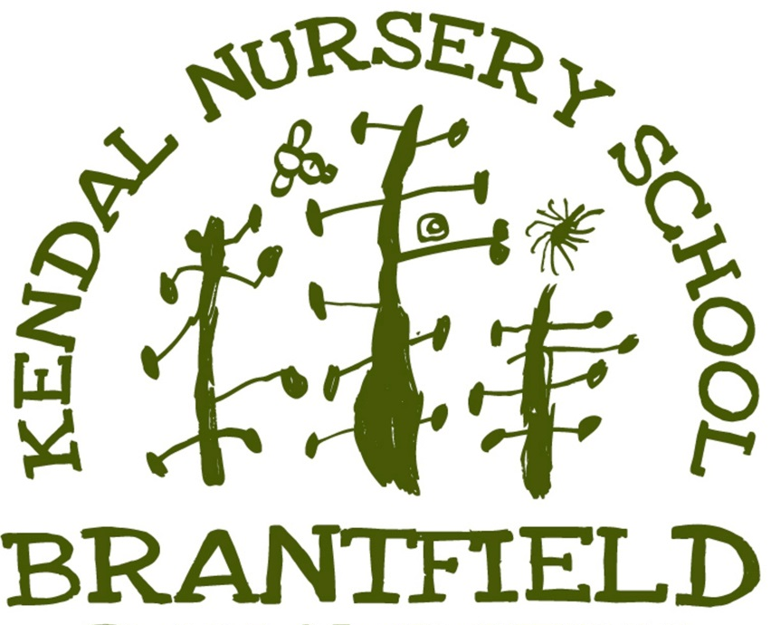

Teaching and Learning Policy

Approved by¹
Name: | Alyssa Dobbs
Position: | Headteacher
Signed: | 
Date: | October 2024
Review date²: | October 2026

Kendal Nursery School – Teaching and Learning Policy
Introduction
At Kendal Nursery School, we believe in fostering a love for learning in every child, drawing inspiration from Maria Montessori’s philosophy that “the goal of early childhood education is to activate a child's natural desire to learn.” This policy outlines our teaching and learning strategies, guided by the principles of curiosity, exploration, and deep engagement. As Xun Kuang said, “Tell me and I'll forget; show me and I may remember; involve me and I'll understand.” Our mission is to involve children fully in their learning journey, cultivating independent, confident, and curious learners.
Rationale
Education at Kendal Nursery School is centred around nurturing strong, curious, and confident children who find joy and fascination in the world around them. We aim to develop children's concentration, commitment, and engagement, empowering them to explore both real and imaginary worlds and to form positive relationships with others. A child who develops a sense of mastery, courage to take risks, and a willingness to learn from mistakes is well-prepared for a lifetime of learning.
We recognise that children are active social learners with an innate ability to make sense of their world through exploration and play. Play is a crucial part of early learning, allowing children to experiment, take risks, and learn from their experiences in a safe and supportive environment. At Kendal Nursery School, play fosters creativity, flexibility, and imagination, helping children to gain control, confidence, and a sense of well-being.
We understand that emotional security is a fundamental prerequisite for learning. Children learn best when they feel emotionally safe and are supported in taking risks. We believe that parents and carers, as the child's first and most enduring educators, play a pivotal role in shaping their child’s development. By working in close partnership with families, we ensure that the curriculum is meaningful and tailored to the individual strengths and interests of each child.
This is achieved through:
- A broad and balanced early years curriculum based on children’s interests, delivered through indoor and outdoor environments.
- High-quality, play-based learning experiences that promote active engagement and communication.
- Strong partnerships with parents, sharing information and fostering meaningful involvement in their child’s learning journey.
- Ongoing assessment to track each child’s development and adapt teaching approaches where necessary.
- Early intervention for children requiring additional support to ensure they receive specialised help as soon as possible.
We believe that high-quality learning and teaching should be the entitlement of every child, equipping them with the skills, knowledge, and understanding necessary to make informed decisions. We acknowledge that every child develops at their own pace, and our approach is tailored to meet the individual needs of each learner. Happiness, security, and active involvement are at the core of effective teaching and learning in the Early Years Foundation Stage (EYFS), helping children progress across all areas of learning and development.
Aims of the Policy
- To establish a broad and balanced EYFS curriculum that supports holistic development and enables every child to reach their full potential.
- To create a safe, dynamic, and inspiring learning environment where children feel empowered and motivated to learn.
- To ensure high-quality learning experiences through play-based activities that promote active engagement and communication.
- To follow children’s passions and interests, shaping individualized learning pathways that celebrate their achievements.
- To foster a lifelong love of learning, particularly through rich outdoor experiences.
- To share good practice among staff and students, ensuring high-quality EYFS experiences for all children.
- To provide a framework for monitoring, evaluation, and school improvement.
Aims for Children
Through effective learning and teaching opportunities, we aim to ensure that all children are:
- Valued as individuals, feeling heard and empowered to make a difference.
- Confident and enthusiastic learners, with high self-esteem and a strong sense of self-worth.
- Independent, creative, and resilient, eager to explore the world and follow their interests.
- Courageous risk-takers, willing to challenge themselves and each other.
- Respectful of themselves, their peers, their communities, and their environment.
- Secure and emotionally attached, developing a sense of belonging and strong relationships.
- Collaborative learners, capable of building positive and supportive relationships with others.
- Aware of themselves as learners, co-constructing meaningful learning experiences and striving for mastery.
- Ambitious, with high aspirations, always building on their previous best to excel in their chosen endeavours.
The Role of Practitioners
Practitioners at Kendal Nursery School play a crucial role in fostering each child’s learning journey. Their responsibilities include:
- Understanding child development and responding to age-appropriate needs, behaviours, and learning.
- Embedding the Keyworker role to support strong emotional attachment and security.
- Recognising patterns of play that may reflect developmental or emotional needs and responding accordingly.
- Celebrating each child’s individuality, honouring their unique interests and learning styles.
- Engaging in high-quality interactions that stimulate thinking and build on children’s strengths and curiosities.
- Encouraging and facilitating social interactions between children and adults, fostering collaboration and empathy.
- Embracing a reflective approach, constantly seeking to improve their own skills and approaches to teaching.
- Supporting children to become mastery learners, encouraging resilience, questioning, risk-taking, and ownership of their learning.
- Ensuring the learning environment is safe, calm, purposeful, and challenging, allowing children to explore confidently.
The Enabling Emotional and Physical Environment
Our daily routine is structured to support a balance of personal exploration, group learning, and social interaction. This routine is designed to:
- Provide opportunities for revisiting and reflecting on previous experiences, fostering deeper engagement through long, uninterrupted explore times.
- Maintain consistency, ensuring that children feel secure and able to act independently within a predictable structure.
- Offer a range of varied and enriching experiences that maintain children’s attention and stimulate learning.
- Establish clear and consistent boundaries, providing children with the confidence to navigate their environment independently.
- Empower children to manage their emotions and resolve conflicts using emotionally supportive practices.
- Provide free-flow access to both indoor and outdoor learning environments, ensuring continuous opportunities for exploration.
- Ensure resources are accessible, plentiful, and well-organized, promoting open-ended exploration and collaborative learning.
Parents in Partnership
At Kendal Nursery School, we recognize that strong parental engagement is essential for a child's success. We view parents as the child's first and most enduring educators, working in close collaboration to support their learning journey. Our aim is to foster two-way communication that strengthens the bond between home and nursery, ensuring a shared responsibility for each child’s development.
We operate an open-door policy that makes parents feel welcome and actively involved in their child's nursery experience. This partnership is built on mutual respect, openness, and collaboration, and is supported by:
- Regular updates via the website, newsletters, and parent evenings to keep parents informed about key events, activities, and their child’s progress.
- A strong ethos of openness and honesty, encouraging parents to share their hopes, concerns, and knowledge of their child with staff.
- Opportunities for parents to engage with the nursery community, celebrating their child’s achievements and progress.
- Clear and consistent communication through various channels, including website updates, texts, newsletters, and in-person meetings.
- Home visits and stay-and-play sessions, providing a smooth and supportive transition from home to nursery and building strong relationships from the beginning.
By maintaining open and honest communication, we create a positive and supportive environment where parents and staff work together to provide the best possible foundation for each child’s success.
Strategies for Learning and Teaching
Our curriculum is planned to offer a wide range of learning experiences that reflect the interests, needs, and passions of the children. Practitioner’s balance face-to-face interaction with structured learning environments that support child-initiated play.
Learning experiences at Kendal Nursery School include:
- Opportunities for children to contribute and make choices in their learning.
- Scaffolding children’s development to support increasing independence.
- Asking questions to stimulate thinking and deepen understanding.
- Encouraging collaborative problem-solving and exploration.
- Providing formative feedback to support children’s reflection and continued growth.
Outdoor Play
We recognize the vital role of outdoor play in promoting children’s overall development, well-being, and health. Our outdoor learning spaces offer safe and stimulating environments for exploration, movement, and creativity.
Key benefits include:
- Supporting the growth of both body and mind through movement and physical activity.
- Offering space and freedom for large-scale investigations.
- Utilizing the natural environment to encourage aesthetic, imaginative, and collaborative play.
- Developing upper body strength and coordination, foundational skills for early writing development.
Planning
At Kendal Nursery School, we use a Child-Cantered approach to planning, ensuring each child’s learning journey is personalized, engaging, and aligned with their unique interests and developmental needs. Our flexible planning allows for child-led exploration, while practitioners collaborate regularly to refine the learning environment, balancing independence with adult support.
In-the-Moment Planning
Planning begins with a deep understanding of each child’s development, interests, and strengths, Practitioners respond flexibly to children’s spontaneous interests, adapting activities in real-time to keep learning meaningful. Written plans act as guides but are regularly adjusted to stay relevant and engaging.
- Continuous Provision: Our environment, both indoors and outdoors, is carefully designed to offer continuous provision. This means the resources and learning areas are consistent and accessible, allowing children to make decisions about what to explore based on their interests. By knowing what children are naturally drawn to in each area, practitioners can subtly enhance and guide learning without interrupting the child’s independent exploration. The environment is continually reflected upon and updated to ensure it is stimulating, well-organized, and supportive of children's developmental needs.
- Enhanced Provision: To enrich the continuous provision, we introduce enhanced provision that builds on children’s current interests, as well as seasonal, cultural, and local events. These enhancements might include interactive displays, specialised resources, or new experiences that extend the children’s learning. Enhanced provision ensures that learning remains dynamic and offers children opportunities to explore topics in greater depth, reflecting the world around them and their personal curiosities.
- Adult-Led Key Experiences: In addition to child-initiated learning, we plan adult-led key experiences. These sessions, held during small or large group times, allow practitioners to introduce new concepts, skills, and knowledge in a focused manner. Adult-led activities are carefully designed to support children’s development in specific areas, whether it’s language acquisition, problem-solving, creative expression, or physical coordination. However, even within these structured times, children are encouraged to engage in active, participatory learning.
Transition from Home to Nursery
The transition from home to nursery is a crucial time for children, and we aim to ensure that each child feels valued, secure, and confident as they begin their nursery experience. A smooth transition helps establish positive relationships and lays the foundation for a lifelong love of learning.
Key Worker System
Each child is assigned a dedicated Key Worker, who serves as the main point of contact for the family and guides the child through their early days at nursery. The Key Worker:
- Builds strong relationships with both the child and parents.
- Monitors the child’s well-being and progress.
- Oversees the child’s Tapestry Learning Journal, documenting their development and key milestones.
Transition Process
Our transition process includes Stay-and-Play Sessions and Home Visits to:
- Establish connections between the child, family, and nursery staff.
- Exchange important information to tailor the settling-in process.
- Gradually increase time spent at nursery, ensuring the child’s emotional well-being.
- Collaborate between rooms to ensure smooth transitions as the child progresses.
Individualised Settling-In
We recognise that every child settles in differently, and we provide a flexible, supportive environment. We gather key information on:
- The child’s confidence and independence.
- Their interests, strengths, and social interactions.
- Help-seeking behaviour and any areas of concern for early intervention.
This approach ensures a positive, well-supported start, fostering both emotional security and learning.

Assessment for Learning
Assessment at Kendal Nursery School is ongoing and integrated into daily learning activities. Observations are used to understand each child’s progress and inform planning.
Tapestry Learning Journal
Throughout their time at Kendal Nursery School, each child’s learning journey is documented in their Tapestry Learning Journal. This is a collaborative tool where staff record key moments of development through observations, photos, and learning stories, and parents are encouraged to contribute. The Tapestry Journal serves as a valuable record of the child’s early years, reflecting both in-nursery and home experiences.
We encourage ongoing dialogue with parents about their child’s development, both informally during drop-off and pick-up times, and through more structured meetings, such as parent consultations. Our aim is to create a shared understanding of the child’s learning journey, celebrating achievements and setting future goals together.
Each child’s progress is tracked termly against EYFS benchmarks, allowing us to celebrate achievements and identify areas for development. We work closely with parents to share insights and collaborate on supporting the child’s continued growth.
Special Needs
We are committed to inclusive education, ensuring all children, including those with special educational needs and disabilities, have access to a supportive and enriching curriculum. Our SENCO works closely with staff, parents, and external agencies to ensure every child receives the support they need to thrive.
Ongoing Observation and Support
As part of our commitment to meeting the needs of all children, including those with Special Educational Needs (SEN) and/or disabilities, we adjust teaching strategies to ensure every child can thrive. Our observations help us:
- Gain a deeper understanding of each child’s development.
- Assess and document progress, identifying next steps for learning.
- Share information with parents and, when appropriate, other professionals to ensure the child receives the best possible support.
- Continuously reflect on our practice, refining our approach to better meet the needs of each child.
Conclusion
Our teaching and learning policy is designed to foster independent, curious, and confident learners who are well-prepared for the next stage of their educational journey. Through strong partnerships with parents, a play-based curriculum, and a supportive environment, we aim to provide every child with the best possible start in life.

